**Java Web开发**

**实验五**

**作业报告**

|  |  |
| --- | --- |
| 学 院 | 计算机 |
| 所在系 班 级 | 2017软件工程系11班 |
| 学 号 姓 名 | 04172215 麦俊艳 |
| 指 导 教 师 | 郭晓燕 |
| 完 成 时 间 | 2019年4月-13 |

# 实验题目

1. 第四章课后练习3购物车，实现一个购物车应用程序，可以购物，显示购物数量并查看购物车内容。（此题模版test4E，提供给大家参考。）

提示：采购此书做成超链接，并用URL重写带关键信息

* 1. Shopping.view?bookID=‘0001’，其中0001是你选中图书对应的ID号，每点击一次就在相应的购书数量上加一，并返回当前的选购页面。
  2. 除了要保存图书的ID号、书名，还要保存购书数量，所以session对象保存的信息需要考虑清楚，最好是一个对象数组或列表。

# 分析与设计

# 关键源码（部分）

Main.jsp:

<%@page import=*"javax.servlet.http.HttpSession"*%>

<%@ page contentType=*"text/html;charset=utf-8"*%>

<html>

<body bgcolor=*yellow*>

<font size=*7*>

<p>

请输入用户名登陆

<form action=*"text.do"* method=*post* name=*form*>

<input type=*"text"* name=*name*>

<input type=*"submit"* name=*submit* value=*"登陆"*>

</form>

<%

String ID=(String)session.getId();

String name=(String)session.getAttribute("name");

**if**(name!=**null**&&name.length()>0)

{

%> <p>登陆成功的id号<%=ID%>

<p>session<a href=*"Shopping.jsp"*>欢迎选购商品</a>

<% }

%>

</font>

</body>

</html>

Transfer.jsp:

package JY;

import java.io.IOException;

import javax.servlet.ServletException;

import javax.servlet.annotation.WebServlet;

import javax.servlet.http.HttpServlet;

import javax.servlet.http.HttpServletRequest;

import javax.servlet.http.HttpServletResponse;

import javax.servlet.http.HttpSession;

@WebServlet("/text.do")

public class Transfer extends HttpServlet {

public void doPost(HttpServletRequest request, HttpServletResponse response)

throws ServletException, IOException {

request.setCharacterEncoding("utf-8");

response.setContentType("text/html,charset=utf-8");

HttpSession session=request.getSession();

String name=request.getParameter("name");

if(name==null)

{

name="";

response.sendRedirect("main.jsp");

}

else

{

session.setAttribute("name",name);

response.sendRedirect("Shopping.jsp");

}

}

}

Shopping.jsp:

<%@ page language=*"java"* import=*"JY.Book,javax.servlet.http.HttpSession"* pageEncoding=*"UTF-8"*%>

<!DOCTYPE HTML PUBLIC "-//W3C//DTD HTML 4.01 Transitional//EN">

<head>

<title>我的购物车</title>

</head>

<html>

<%

**if**(session.getAttribute("bookList")==**null**)

{

Book[] bookList = **new** Book[4];

bookList[0]=**new** Book("1","Java&Servlet","img/1.png",0);

bookList[1]=**new** Book("2","Java经典实例","img/2.png",0);

bookList[2]=**new** Book("3","Java核心技术","img/3.png",0);

bookList[3]=**new** Book("4","Java7","img/4.png",0);

session.setAttribute("bookList",bookList);

session.setAttribute("num",0);

}

%>

<%

Book[] books = (Book[])session.getAttribute("bookList");

**int** num = (Integer)session.getAttribute("num");

%>

<p>请选择采购的书籍</p>

<a href=*"order.jsp"*>当前已采购<%=num%>本书籍</a><br>

<%

**if**(books != **null**){

**int** []sale={1,2,3,4};

session.setAttribute("sale",sale);

**for**(**int** i=0;i<books.length;i++){

%>

<div style="float: *left*">

<img style="width:*150px* ;height:*200*" src=*"*<%=books[i].getBookImg() %>*"*><br>

<a href=*"shopping.view?id=*<%=books[i].getBookId()%>*"*><img src=*"img/6.jpg"* width=*"25"* height=*"25"* alt=*"加一本"*></a>

<a href=*"shopping.view?id=*<%=(books[i].getBookId()+10)%>*"*><img src=*"img/7.jpg"* width=*"25"* height=*"25"* alt=*"减一本"*></a><br>

价格:<%=sale[i]+"/本"%> <br>

</div>

<%

}

%>

<br>

<details>

<summary>详情</summary>

<p>出版社：清华大学出版社</p>

<p>著作人:林信良</p>

</details>

<details>

<summary>详情</summary>

<p>出版社：清华大学出版社</p>

<p>著作人:林信良</p>

</details>

<details>

<summary>详情</summary>

<p>出版社：清华大学出版社</p>

<p>著作人:林信良</p>

</details>

<details>

<summary>详情</summary>

<p>出版社：清华大学出版社</p>

<p>著作人:林信良</p>

</details>

<%

}%>

</html>

Order.jsp:

<%@ page language=*"java"* import=*"java.util.*"* contentType=*"text/html; charset=utf-8"*%>

<%@ page import=*"JY.Book"* %>

<%

String path = request.getContextPath();

String basePath = request.getScheme()+"://"+request.getServerName()+":"+request.getServerPort()+path+"/";

%>

<!DOCTYPE HTML PUBLIC "-//W3C//DTD HTML 4.01 Transitional//EN">

<html>

<head>

<base href=*"*<%=basePath%>*"*>

<title>My JSP 'order.jsp' starting page</title>

</head>

<body>

<%

Book[] books = (Book[])session.getAttribute("bookList");

**int** num= (Integer)session.getAttribute("num");

%>

<a href=*"Shopping.jsp"*>返回选购</a>

<form action=*"caluate.jsp"* method=*post*>

<%

**if**(books != **null**){

**for**(**int** i=0;i<books.length;i++){

out.println("<br>");

out.println("<tr>");

out.println("<td><img src='"+books[i].getBookImg()+"' height='auto' width='100px'></td>");

out.println("<td>已选"+books[i].getName()+"</a></td>");

out.println("<td>"+books[i].getNum()+"本</td>");

out.println("</tr>");

out.println("<br>");

}

}%>

<hr>

<input type=*"submit"* value=*"提交结算购买"* name=*"money"* >

</form>

</body>

</html>

Caluate.jsp:

<%@page import=*"javax.servlet.http.HttpSession"*%>

<%@ page contentType=*"text/html;charset=utf-8"*%>

<%@ page import=*"JY.Book"* %>

<html>

<body>

<font size=*"7"* face=*"宋体"* color=*red*>

<%

Book[] books = (Book[])session.getAttribute("bookList");

**int** num= (Integer)session.getAttribute("num");

**int** []sale=(**int** [])session.getAttribute("sale");

**int** all=0;

**for**(**int** i=0;i<books.length;i++)

{

all+=(sale[i]*books[i].getNum());

%>

<img style="width:*150px* ;height:*200*" src=*"*<%=books[i].getBookImg() %>*"*>

<%

out.println("<td>"+books[i].getName()+" "+"合算为:"+sale[i]*books[i].getNum()+"元</td>");

out.println("<br>");

}

out.println("<br>");

out.println("总价为："+all+"元");

%>

</font>

</body>

</html>

Carservlet.java:

package JY;

import java.io.IOException;

import java.io.PrintWriter;

import javax.servlet.ServletException;

import javax.servlet.annotation.WebServlet;

import javax.servlet.http.HttpServlet;

import javax.servlet.http.HttpServletRequest;

import javax.servlet.http.HttpServletResponse;

import javax.servlet.http.HttpSession;

@WebServlet("/shopping.view")

public class Carservlet extends HttpServlet {

public void doGet(HttpServletRequest request, HttpServletResponse response) throws ServletException, IOException {

doPost(request, response);

}

public void doPost(HttpServletRequest request, HttpServletResponse response) throws ServletException, IOException {

response.setContentType("text/html;charset=utf-8");

request.setCharacterEncoding("UTF-8");

HttpSession session = request.getSession();

Book[] bookList = (Book[]) session.getAttribute("bookList");

PrintWriter out = response.getWriter();

for (Book book : bookList) {

if(request.getParameter("id").equals(book.getBookId()))

{

book.setNum(book.getNum()+1);

session.setAttribute("num", (Integer)session.getAttribute("num")+1);

}

else if(request.getParameter("id").equals((book.getBookId()+10))&& book.getNum()!=0)

{

book.setNum(book.getNum()-1);

session.setAttribute("num", (Integer)session.getAttribute("num")-1);

}

}

response.sendRedirect("Shopping.jsp");

}

}

Book.java:

package JY;

import java.io.IOException;

import javax.servlet.ServletException;

import javax.servlet.http.HttpServlet;

import javax.servlet.http.HttpServletRequest;

import javax.servlet.http.HttpServletResponse;

import javax.servlet.http.HttpSession;

public class Book {

String ID;

String Name;

String imageUrl;

double price;

int Num;

public Book(String iD, String name, String imageUrl, int num) {

ID = iD;

Name = name;

this.imageUrl = imageUrl;

Num = num;

}

public String getBookId() {

return ID;

}

public void setID(String iD) {

ID = iD;

}

public String getName() {

return Name;

}

public void setName(String name) {

Name = name;

}

public String getBookImg() {

return imageUrl;

}

public void setImageUrl(String imageUrl) {

this.imageUrl = imageUrl;

}

public int getNum() {

return Num;

}

public void setNum(int num) {

Num = num;

}

public double getPrice() {

return price;

}

public void setPrice(double price) {

this.price = price;

}

}

# 运行效果图

Main.jsp: 运行首页

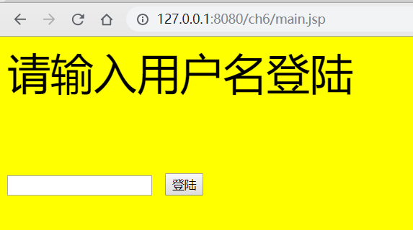

Shopping.jsp: 选购页面：通过加减号选择课本数量

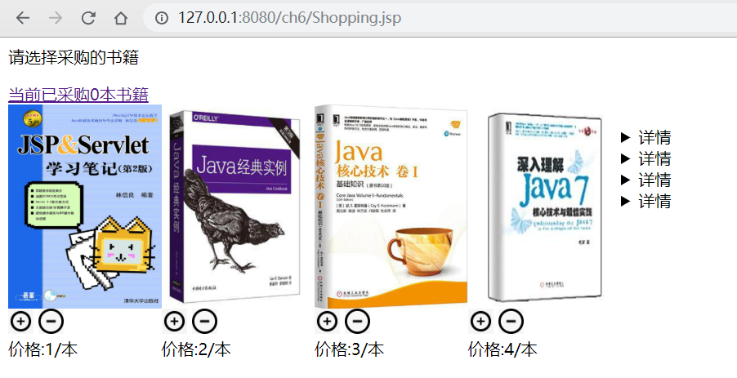

Order.jsp: 类似购物车页面，总结所购买的书籍清单

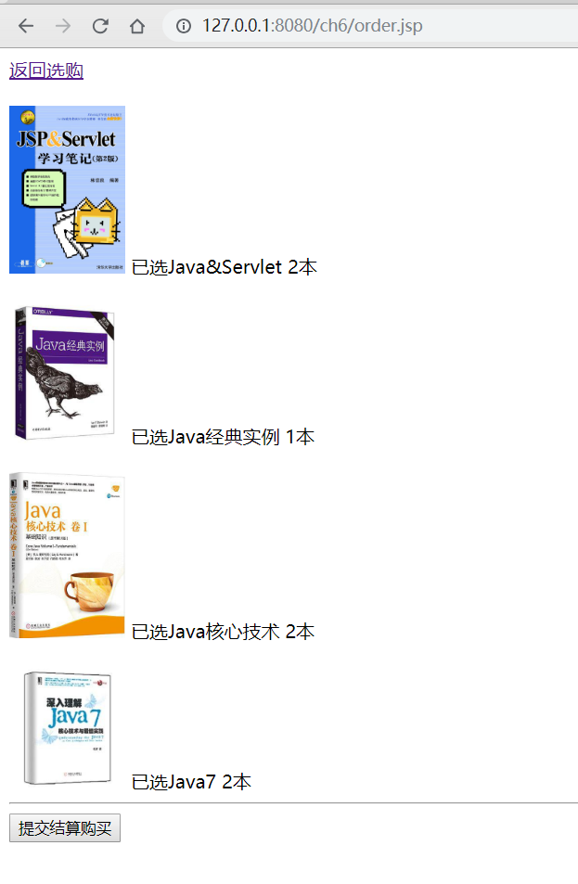

Caluate.jsp:

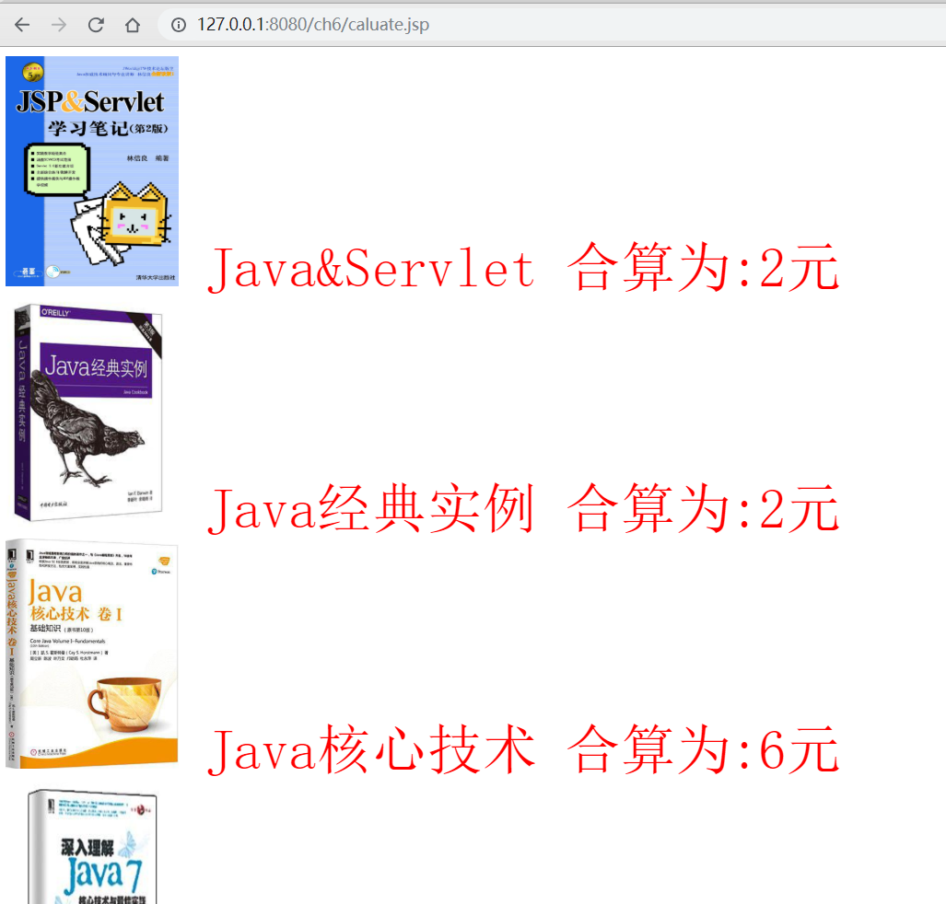

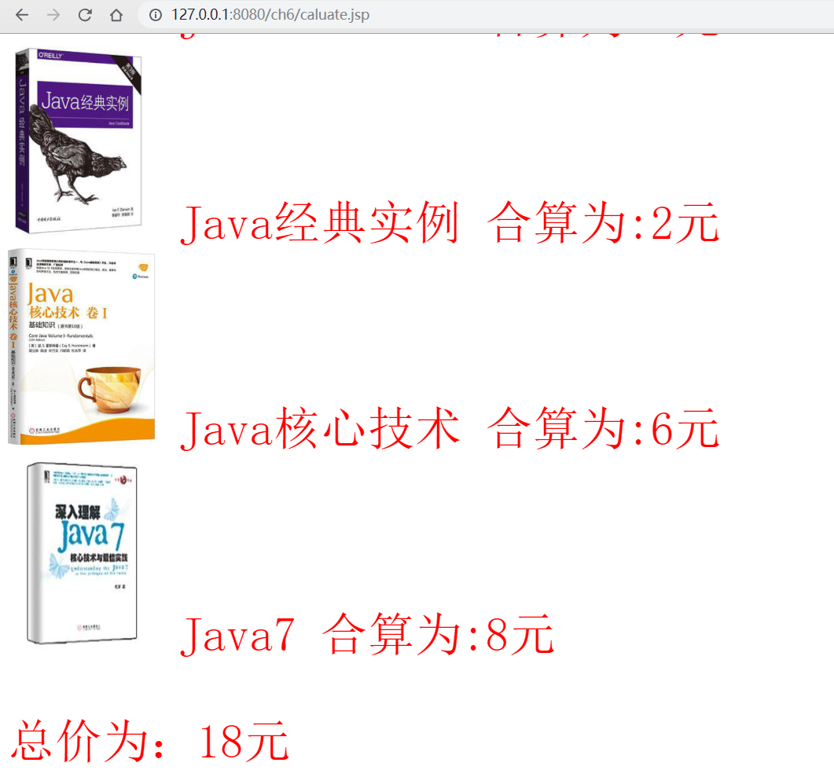

# 收获与问题

进一步熟练Servlet中session应用。